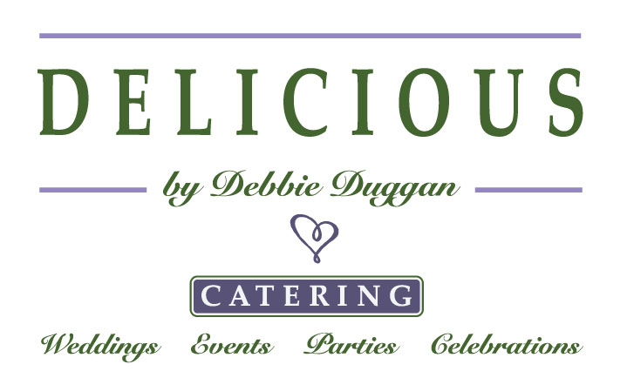
~ WEDDING CATERING INQUIRY QUESTIONAIRE ~

Thank you so much for contacting DELICIOUS by Debbie Duggan.
I am available on your requested date and look forward to the possibility
of working with you to create an unforgettable wedding day!

I consider myself a boutique caterer. My food is all made from scratch, sourced
from local and seasonal ingredients, and above all, high quality and delicious.
I only cater three weddings per month to ensure I have enough time to spend with my brides and grooms and their menus. My staff is well-trained, friendly, and professional.

I want to know more about what you envision the food at your wedding to be.
Please fill out this short questionnaire. In return, I will create a personalized menu for you to review, based on your preferences, seasonality of ingredients, and budget. This personalized menu will also include pricing per person.

1. Wedding Date:
      - Time and location of ceremony:
      - Time and location of reception:
      - Number of anticipated guests:
      - Name of wedding planner, if using

      - Do you need help with securing rentals (tables, chairs, linens, glassware, flatware, etc…)?

      - Will you need beverage service at the wedding site (ie, lemonade, ice tea, spa water)?
      - Will you need bar service for the reception? (Please note, bride/groom to provide all alcohol and we are able to provide bartending service).

2. What are some of your absolute favorite foods, meals, and dishes?
Feel free to include appetizers, salads, vegetables, and entrees.

3. What type of cuisine/food do you envision at your wedding?

4. Are there any foods that you would like to avoid being served at your wedding, due to dislike or allergies?

5. Describe what you anticipate the ambiance of your wedding to be? For example, do you want your wedding to be a formal affair, more rustic, or California chic?

6. Which food serving style are you interested in:
Plated
Family style
Partially-plated served buffet (salad is plated, the rest of the m meal is served buffet-style)

7. What would you like to do for dessert service? (traditional cake, dessert bar, etc…)

8. Is there anything else you would like to share with me as I put together your customized menu?

9. What is the email address/addresses you would like me to send your personalized menu back to?

Thank you for taking the time to answer these questions. Please email this completed questionnaire (please save as Microsoft Word or PDF) to: chefdebbiedugg@gmail.com.

We will respond as soon as we can!

Warmly,
Debbie
DELICIOUS by Debbie Duggan
Cell: (805) 550-5081

*Vegetarian, vegan, and children’s menus available upon request.
**Please inform me of any food allergies, as they arise when collecting RSVPs.
***I do not charge extra for cake or dessert service (ie, cake cutting).
****If you are interested the menu I have created for your wedding, we can discuss how to move forward, including scheduling a tasting.

